特征选择工作流的实体化优化
Ce Zhang†‡ Arun Kumar† Christopher Ré‡ †University of Wisconsin-Madison, USA ‡Stanford University, USA {czhang,chrismre}@cs.stanford.edu, arun@cs.wisc.edu
摘要
在支持分析的数据管理行业有一个军备竞赛，其中非常重要的一步就是会被用来构建一个统计模型的特征选择过程。分析是数据管理中最重要的一个话题之一，而特征选择被视为分析中最重要的一步，因此我们认为管理特征选择过程是一个紧急的数据管理挑战。我们通过描述一个特征选择语言和一个支持的构建于现有行业基础之上的原型系统-R集成层来研究这个挑战。在我们与分析师的互动中，我们发现特征选择是一个交互性的、人工参与的过程，这就意味着特征选择工作流充斥着重用的机会。因此，我们不仅使用经典的数据库物化优化，而且使用了在数据库优化中以前没有使用过的方法，包括结构化分解方法(像QR因式分解)和热启动来研究如何具体化计算的一部分。这些新方法在传统的SQL系统中没有模拟，但是他们可能会对数组和科学数据库应用感兴趣。在一组不同的数据集和程序中，我们发现忽略了这些新机会的传统的数据库风格方法比一个权衡了多个R-后端空间优化的方案慢两个维度。因此，我们认为构建一个简单的基于消耗的来自动的为特征选择选择几乎最优的执行方案的优化器是可行的。
分类和主题描述
H.2 [信息系统]: 数据库管理
关键字
统计分析；特征选择；实体化
为个人或者课堂使用授权制作部分或者该作品的全部的数字或者硬拷贝是免费的，假设复制品不被制作或者为了商业利益发布并且复制品保留该封面的全部引用。该作品的部分被除了ACM拥有的版权需要授权。收费摘要是允许的。复制、重新发布、发布到服务器或者重新发布到列表，需要提前特殊的授权和费用。从permissions@acm.org 这里来获得授权。
SIGMOD’14, June 22–27, 2014, Snowbird, UT, USA. Copyright 2014 ACM 978-1-4503-2376-5/14/06 ...$15.00. http://dx.doi.org/10.1145/2588555.2593678.
1. 介绍
在数据分析过程中最重要的一步就是特征选择；在特征选择过程中，一个分析员选择输入或者一个模型的特征来帮助提高模型的准确性或者帮助一个分析员理解并且探索他们的数据。随着数据分析兴趣的增加，一个紧急的挑战就是提高特征选择过程的效率。在这个工作中我们提出了Columbus这个第一个被设计用来支持企业级特征选择过程的数据处理系统。
要理解特征选择的做法，我们采访了有企业背景的分析员。这其中包括一个保险公司，一个咨询公司，一个主要的数据库厂商分析客户，一个主要的电子商务公司。毫无例外，分析员都同意他们在特征选择过程中花费了大量的时间。通过阅读特征选择文献[20,25]，我们发现特征被选择(或者不)有很多原因：它们的统计学表现，他们在真实世界中的解释力，法律原因1，或者一些原因的组合。因此，特征选择在实践中是一个分析员参与其中的交互过程。分析员使用特征选择算法，数据统计和作为对话的经常对他们的应用领域特别的数据操作[6]。然而，特征选择过程是有结构的：分析员经常使用特定领域的手册来勾勒出最佳的特征选择实践[2,7,20]。
虽然特征选择手册被广泛使用，分析员仍然必须写低级的代码，在R中逐渐增多，来运行手册中组成一个特征选择任务的子任务。特别的，我们还观察到这样的用户被迫写他们自定义的R类库来实现特征选择过程中简单的常用的操作(比如,跨步增加或者删除[20])。在过去的这些年中，数据库厂商已经注意到了这个趋势，并且现在，大多数数据库引擎都一个R扩展产品：Oracle’s ORE [4], IBM’s System ML [17], SAP HANA [5], 和Revolution Analytics on Hadoop and Teradata。这些R-扩展层(RELs)透明的扩展操作，比如从矩阵向量乘法或者行列式到不同后端的大量数据集，包括多核主存，数据库引擎和Hadoop。我们把这些REL操作叫做ROPs。扩展ROPs在工业界广泛的使用。
然而 ，我们发现一个主要的在分析员代码中的低效源头没有被ROP优化所解决：被重用的缺失值机会和跨ROP实体化。我们的第一个贡献就是展示了一个少量的能够在数量级上提高性能的实体化优化。选择最佳的实体化策略对分析员来说是比较困难的，因为最佳方案是由这个特征选择任务被重用的机会，分析员能容忍的错误率，数据属性和计算节点，比如平行化和数据大小决定的。因此，一个最佳的用R脚本对一个数据集的实体化策略可能对同样的任务在另外一个数据集上不是最佳策略。因此，对分析员选择正确的实体化优化结合是比较困难的。
为了学习这些权衡，我们介绍了Columbus，一个被设计为特征选择的R语言扩展和执行框架。使用Columbus，用户首先写一个标准的R程序，Columbus提供了一个有常见特征选择操作的类库，比如逐步增加。比如，“将每一个特征加到当前特征集并且解决”。这个类库复制了特征选择中最常用的一些操作[20]和我们在分析员程序中所观察到的。Columbus的优化器使用这些高层次的，声明性构造去识别数据和计算重用性的几率。为了描述Columbus使用的优化策略，我们介绍一个基本的块操作概念。
一个基本块是Columbus的主要优化单元。一个基本块为概括的线性模型捕获特征选择，这些线性模型包括线性、逻辑回归、支持向量机、套索和更多，看2.1的定义。大概，一个基本块B包含一个数据矩阵A ∈ RN×d,其中N是样例的个数，d是特征的个数，一个目标b ∈ RN，一些特征集(A列的子集)，和一个(凸)损失函数。一个基本块在相同的数据集上(每个特征集对应一个回归问题)定义了一系列回归问题。Columbus将程序编译成基本块的序列，这些基本块是已经优化过的并且将会被转化为ROP。我们的目标不是提高ROP的性能，而是使用广泛存在的ROP来提高特征选择工作流的表现。
我们描述了Columbus视为一个基本块的重用和实体化的机会。作为一个基线，我们实现了经典的批处理和实体化优化。另外，我们识别出了3种新奇的优化类别，研究了每种类型表现出来的优缺点，然后阐述了一个允许Columbus从中选择的消耗模型。这些优化很新奇是因为它们没有在传统的SQL风格分析中被考虑过(但是所有的这些优化都已经在其他领域实现了)。
子采样 分析员采用子采样来减少系统所需要处理的数据来提高运行效率和减少过度拟合。这些方法对分析员都是一个自然的选择，因为底层的数据收集处理和解决方案只对一些容忍性有效。流行的取样方法包括朴素随机采样和重要性采样(核心集)。核心集是一个近期重要性采样方法。当d ≪ N时，核心集允许创建一个大小由d(特征的数量)决定的样本—到N(例子的数量)—那样会得到强优化结果：本质上，任何模型的损失是保存在样本上的。在企业工作流中(比如web工作流)，我们发现过度决定问题(d ≪ N)，经典统计学的研究都是非常常见的。因此，我们使用一个核心集以一个可证明的小错误来优化结果。然而，计算一个核心集需要计算比一个朴素随机取样更昂贵的重要分数。我们基于取样实体化策略研究了支出—收益交易。当然，取样策略有提高数量级别的性能的能力。在一个叫做Census的真实数据集上，我们发现d比N小1000x，并且使用核心集产生了一个接近89x的基线，仍然得到了一个在整个数据及和尚损失1%的解决方案。
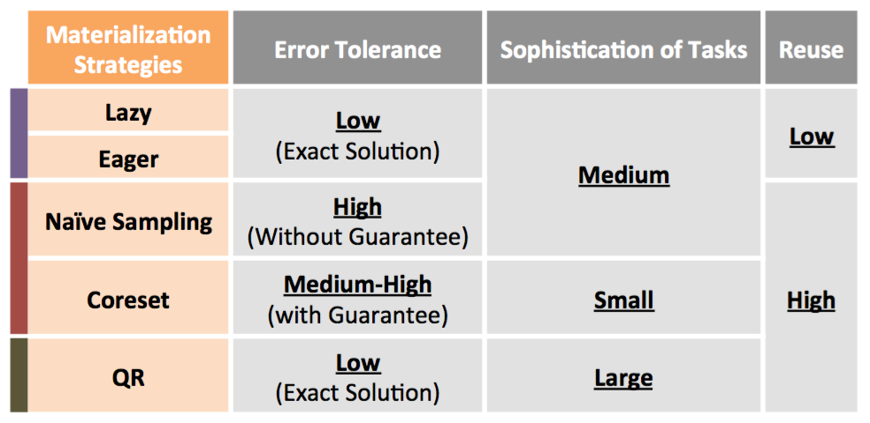
图 1: Columbus 的利弊总结

转换实体化 线性代数有众多类似复杂实体化视图的分解。这其中的一个分解，叫做(瘦)QR分解，被广泛的用来优化回归问题。本质上，经过一些预处理，一个QR分解允许我们通过一次扫描矩阵就可以解决一类回归问题。在特征选择中，人们不得不解决很多类似的与此相关的回归问题。例如，对于很多特征(例如A列)的子集。我们展示了对于这种场景如何适应QR。当可以应用时，QR可以达到超过10X的基线，QR也可以与核心集应用到一起，这样可以加速5倍以上。当然，当实体化QR的时候这里有一个成本收益的权衡，并且Columbus为这种选择提供了一个简单的成本模型。
模型缓存 特征选择工作要求分析员解决很多类似的问题。直观的看，重用这些部分结果来“热启动”一个模型并且提高它的收敛行为应当是可行的。我们提出了缓存一些模型，并且开发了一个选择哪个模型来热启动的方法。这其中的挑战就是能够找到一个“附近”的模型，然后我们提出了一个为模型缓存的简单启发式。与R中默认的方法相比(以一个随机数初始化或者全部为0)，我们的启发式速度提高了13倍。与从缓存中选择一个随机模型这个简单的策略，我们的启发式速度提高了6倍。因此，缓存和启发式结合到一起提高了我们的运行效率。
我们在三种相关的轴上梳理出了优化空间，这三种轴包括：容错率、任务的复杂度和重用的次数（图3）。图1总结了这些轴和权衡的关系。当然，正确的选择也取决于计算限制，值得注意的是并行化。我们实行了一系列的实验来验证权衡空间并且发现没有任何一个策略操控其他。因此，我们开发了一个基于消耗的优化器以试图选择一个可选的上述实体化策略的结合。我们验证了我们的启发式优化器在所有的工作流上有10%的可选优化方案(靠离线蛮力发现的)。在完整的版本中，我们发现优化器的很多子问题是经典的难NP，因此验证了我们的启发式优化器。
Contributions. This work makes three contributions: (1) We propose Columbus, which is the first data processing system designed to support the feature selection dialogue; (2) we are the first to identify and study both existing and novel optimizations for feature selection workloads as data management problems; and (3) we use the insights from (2) to develop a novel cost-based optimizer. We validate our re- sults on several real-world programs and datasets patterned after our conversations with analysts. Additionally, we val- idate Columbus across two backends from main memory and REL for an RDBMS. We argue that these results sug- gest that feature selection is a promising area for future data management research. Additionally, we are optimistic that the technical optimizations we pursue apply beyond feature selection to areas like array and scientific databases and tun- ing machine learning.
Outline. The rest of this paper is organized as follows. In Section 2, we provide an overview of the Columbus system. In Section 3, we describe the tradeoff space for executing a feature selection program and our cost-based optimizer. We describe experimental results in Section 4. We discuss related work in Section 5 and conclude in Section 6.
The key task of Columbus is to compile and optimize an extension of the R language for feature selection. We com- pile this language into a set of REL operations, which are R-language constructs implemented by today’s language ex- tenders, including ORE, Revolution Analytics, etc. One key design decision in Columbus is not to optimize the execu- tion of these REL operators; these have already been studied intensively and are the sub jects of ma jor ongoing engineer- ing efforts. Instead, we focus on how to compile our language into the most common of these REL operations (ROPs). Figure 5 shows all ROPs that are used in Columbus.
2. 2.1
Figure 4: Architecture of Columbus.
SYSTEM OVERVIEW Columbus Programs

Figure 3: Summary of Operators in Columbus.
#&'$(' "740*8(' 12(+36-'
Columbus #'-/'&0 )&$*+ ),-+.$ !"#$ 12(+34-5 !($3,6
!"#$%$&'%()!*+ -./"0'$%12'&'%(-/3 -4+ -.4"0'$%12'&'%(-5+ -.5"&%'6#276(!3 -./+ -.8"9:;<:(-.53 -.4+
-.8
9:;<:
-.4
J2(!K3-./L+ M$EF.7?N'(O+ M$EF.7?N'(O+ 9:;<:
-./"=-/3-4> -.4"=-5> -.5"=-/> -.8"=-/3 -5>
C$.DE C?7EF &%$GH$2H A<I
!3 ?7.."@A3 B 0/"=-/>3 04"=-4>
In Columbus, a user expresses their feature selection pro- gram against a set of high-level constructs that form a do- main specific language for feature selection. We describe these constructs next, and we selected these constructs by talking to a diverse set of analysts and following the state-of- the-art literature in feature selection. Columbus’s language is a strict superset of R, so the user still has access to the full power of R.2 We found that this flexibility was a requirement for most of the analysts surveyed. Figure 2 shows an exam- ple snippet of a Columbus program. For example, the 9th line of the program executes logistic regression and reports its score using cross validation.
Columbus has three major datatypes: A data set, which is a relational table R(A1,...,Ad).3 A feature set F for a dataset R(A1,...,Ad) is a subset of the attributes F ⊆ {A1,...,Ad}. A model for a feature set is a vector that assigns each feature a real-valued weight. As shown in Fig- ure 3, Columbus supports several operations. We classify these operators based on what types of output an operator produces and order the classes in roughly increasing order of the sophistication of optimization that Columbus is able to perform for such operations (see Figure 3 for examples): (1) Data Transformation Operations, which produce new data sets; (2) Evaluate Operations, which evaluate data sets and models; (3) Regression Operations, which produce a model given a feature set; and (4) Explore Operations, which pro- duce new feature sets:
(1) Data Transform. These operations are standard data manipulations to slice and dice the dataset. In Colum- bus, we are aware only of the schema and cardinality of these operations; these operations are executed and optimized di-
2We also have expressed the same language over Python, but for simplicity, we stick to the R model in this paper. 3Note that the table itself can be a view; this is allowed in
Columbus, and the tradeoffs for materialization are stan- dard, so we omit the discussion of them in the paper.
267
rectly using a standard RDBMS or main-memory engine. In R, the frames can be interpreted either as a table or an array in the obvious way. We map between these two representa- tions freely.
(2) Evaluate. These operations obtain various numeric scores given a feature set including descriptive scores for the input feature set, e.g., mean, variance, or Pearson cor- relations and scores computed after regression, e.g., cross- validation error (e.g., of logistic regression), and Akaike In- formation Criterion (AIC) [20]. Columbus can optimize these calculations by batching several together.
(3) Regression. These operations obtain a model given a feature set and data, e.g., models trained by using logistic regression or linear regression. The result of a regression operation is often used by downstream explore operations, which produces a new feature set based on how the pre- vious feature set performs. These operations also take a termination criterion (as they do in R): either the number of iterations or until an error criterion is met. Columbus supports either of these conditions and can perform opti- mizations based on the type of model (as we discuss).
(4) Explore. These operations enable an analyst to tra- verse the space of feature sets. Typically, these operations result in training many models. For example, a StepDrop operator takes as input a data set and a feature set, and outputs a new feature set that removes one feature from the input by training a model on each candidate feature set. Our most sophisticated optimizations leverage the fact that these operations operate on features in bulk. The other ma- jor operation is StepAdd. Both are used in many workloads and are described in Guyon et al. [20].
Columbus is not intended to be comprehensive. However, it does capture the workloads of several analysts that we observed, so we argue that it serves as a reasonable starting point to study feature selection workloads.
2.2 Basic Blocks
In Columbus, we compile a user’s program into a directed- acyclic-dataflow graph with nodes of two types: R functions and an intermediate representation called a basic block. The R functions are opaque to Columbus, and the central unit of optimization is the basic block (extensible optimizers [19]).
Definition 2.1. A task is a tuple t = (A,b,l,ǫ,F,R) whereA∈RN×d isadatamatrix,b∈RN isalabel(or target),l:R2 →R+ isalossfunction,ǫ>0isanerror tolerance, F ⊆ [d] is a feature set, and R ⊆ [N] is a subset of rows. A task specifies a regression problem of the form:
Lt(x) = l(zi,bi) s.t. z = AΠF x i∈R
HereΠF istheaxis-alignedprojectionthatselectsthecolumns or feature sets specified by F.4 Denote an optimal solution of the task x∗(t) defined as
x∗(t) = argminLt(x) x∈Rd
4ForF ⊆[d],ΠF ∈Rd×d where(ΠF)ii =1ifi∈F andall other entries are 0.
Our goal is to find an x(t) that satisfies the error5 ∥Lt(x(t)) − Lt(x∗(t))∥2 ≤ ǫ
A basic block, B, is a set of tasks with common data (A, b) but with possibly different feature sets F ̄ and subsets of rows R ̄.
Columbus supports a family of popular non-linear mod- els, including support vector machines, (sparse and dense) logistic regression, lp regression, lasso, and elastic net regu- larization. We give an example to help clarify the definition.
Example 2.1. Consider the 6th line in Figure 2, which specifies a 5-fold cross validation operator with least squares over data set d1 and feature set s1. Columbus will generate a basic block B with 5 tasks, one for each fold. Let ti = (A,b,l,ǫ,F,R). Then, A and b are defined by the data set d1 andl(x,b)=(x−b)2. Theerrortoleranceǫisgivenby the user in the 1st line. The projection of features F = s1 is found by a simple static analysis. Finally, R corresponds to the set of examples that will be used by the ith fold.
The basic block is the unit of Columbus’s optimization. Our design choice is to combine several operations on the same data at a high-enough level to facilitate bulk optimiza- tion, which is our focus in the next section.
Columbus’s compilation process creates a task for each regression or classification operator in the program; each of these specifies all of the required information. To enable arbitrary R code, we allow black box code in this work flow, which is simply executed. Selecting how to both optimize and construct basic blocks that will execute efficiently is the subject of Section 3.
REL Operations. To execute a program, we compile it into a sequence of REL Operations (ROPs). These are operators that are provided by the R runtime, e.g., R and ORE. Fig- ure 5 summarizes the host-level operators that Columbus uses, and we observe that these operators are present in both R and ORE. Our focus is how to optimize the compilation of language operators into ROPs.
2.3 Executing a Columbus Program
To execute a Columbus program, our prototype contains three standard components, as shown in Figure 4: (1) parser; (2) optimizer; and (3) executor. At a high-level, these three steps are similar to the existing architecture of any data pro- cessing system. The output of the parser can be viewed as a directed acyclic graph, in which the nodes are either ba- sic blocks or standard ROPs, and the edges indicate data flow dependency. The optimizer is responsible for generat- ing a “physical plan.” This plan defines which algorithms and materialization stategies are used for each basic block; the relevant decisions are described in Sections 3.1 and 3.2. The optimizer may also merge basic blocks together, which is called multiblock optimization, which is described in Sec- tion 3.4. Finally, there is a standard executor that manages the interaction with the REL and issues concurrent requests.
5We allow termination criteria via a user-defined function or the number of iterations. The latter simplifies reuse cal- culations in Section 3, while arbitrary code is difficult to analyze (we must resort to heuristics to estimate reuse). We present the latter as the termination criterion to simplify the discussion and as it brings out interesting tradeoffs.
268
3. THE Columbus OPTIMIZER
We begin with optimizations for a basic block that has a least-squares cost, which is the simplest setting in which Columbus’s optimizations apply. We then describe how to extend these ideas to basic blocks that contain nonlinear loss functions and then describe a simple technique called model caching.
Optimization Axes. To help understand the optimization space, we present experimental results on the Census data set using Columbus programs modeled after our experience with insurance analysts. Figure 6 illustrates the crossover points for each optimization opportunity along three axes that we will refer to throughout this section:6
(1) Error tolerance depends on the analyst and task. For intuition, we think of different types of error tolerances, with two extremes: error tolerant ǫ = 0.5 and high quality ǫ = 10−3 . In Figure 6, we show ǫ ∈ {0.001, 0.01, 0.1, 0.5}.
(2) Sophistication of the feature selection task, namely the loss function (linear or not), the number of feature sets or rows selected, and their degree of overlap. In Figure 6, we set the number of features as {10, 100, 161} and the number of tasks in each block as {1, 10, 20, 50}.
(3) Reuse is the degree to which we can reuse computa- tion (and that it is helpful to do so). The key factors are the amount of overlap in the feature sets in the workloads7 and the number of available threads that Columbus uses, which we set here to {1, 5, 10, 20}.8
We discuss these graphs in paragraphs marked Tradeoff and in Section 3.1.4.
3.1 A Single, Linear Basic Block
We consider three families of optimizations: (1) classical database optimizations, (2) sampling-based optimizations, and (3) transformation-based optimizations. The first opti- mization is essentially unaware of the feature-selection pro- cess; in contrast, the last two of these leverage the fact that we are solving several regression problems. Each of these optimizations can be viewed as a form of precomputation (materialization). Thus, we describe the mechanics of each optimization, the cost it incurs in materialization, and its cost at runtime. Figure 5 summarizes the cost of each ROP and the dominant ROP in each optimization. Because each ROP is executed once, one can estimate the cost of each materialization from this figure.9
To simplify our presentation, in this subsection, we let l(x, b) = (x − b)2, i.e., the least-squares loss, and suppose that all tasks have a single error ε. We return to the more
6For each combination of parameters below, we execute Columbus and record the total execution time in a main memory R backend. This gives us about 40K data points, and we only summarize the best results in this paper. Any omitted data point is dominated by a shown data point. 7Let G = (∪F ∈F ̄ F, E) be a graph, in which each node cor- responds to a feature. An edge (f1,f2) ∈ E if there exists F ∈ F ̄ such that f1,f2 ∈ F. We use the size of the largest connected component in G as a proxy for overlap.
8Note that Columbus supports two execution models, namely batch mode and interactive mode. 9We ran experiments on three different types of machines to validate that the cost we estimated for each operator is close to the actual running time. In the full version of this
paper, we show that the cost we estimated for one operator is within 15% of the actual execution time.
general case in the next subsection. Our basic block can be simplified to B = (A, b, F ̄, R ̄, ε), for which we compute:
x(R,F)=argmin∥ΠR(AΠFx−b)∥2 whereR∈R ̄,F ∈F ̄ x∈Rd
Our goal is to compile the basic block into a set of ROPs. We explain the optimizations that we identify below.
3.1.1 Classical Database Optimizations
We consider classical eager and lazy view materialization schemes. Denote F ∪ = ∪F ∈F ̄ F and R∪ = ∪R∈R ̄ in the basic block. It may happen that A contains more columns than F∪ and more rows than R∪. In this case, one can project away these extra rows and columns—analogous to materialized views of queries that contain selections and pro- jections. As a result, classical database materialized view optimizations apply. Specially, Columbus implements two strategies, namely Lazy and Eager. The Lazy strategy will compute these projections at execution time, and Eager will compute these projections at materialization time and use them directly at execution time. When data are stored on disk, e.g., as in ORE, Eager could save I/Os versus Lazy.
Tradeoff. Not surprisingly, Eager has a higher materializa- tion cost than Lazy, while Lazy has a slightly higher ex- ecution cost than Eager, as one must subselect the data. Note that if there is ample parallelism (at least as many threads as feature sets), then Lazy dominates. The stan- dard tradeoffs apply, and Columbus selects between these two techniques in a cost-based way. If there are disjoint feature sets F1 ∩ F2 = ∅, then it may be more efficient to materialize these two views separately. In the full paper, we show that the general problem of selecting an optimal way to split a basic block to minimize cost is essentially a weighted set cover, which is NP-hard. As a result, we use a simple heuristic: split disjoint feature sets. With a fea- ture selection workload, we may know the number of times a particular view will be reused, which Columbus can use to more intelligently chose between Lazy and Eager (rather than not having this information). These methods are insen- sitive to error and the underlying loss function, which will be major concerns for our remaining feature-selection-aware methods.
3.1.2 Sampling-Based Optimizations
Subsampling is a popular method to cope with large data and long runtimes. This optimization saves time simply be- cause one is operating on a smaller dataset. This optimiza- tion can be modeled by adding a subset selection (R ∈ R ̄) to a basic block. In this section, we describe two popular methods: na ̈ıve random sampling and a more sophisticated importance-sampling method called coresets [11,27]; we de- scribe the tradeoffs these methods provide.
Naïve Sampling. Na ̈ıve random sampling is widely used, and in fact, analysts ask for it by name. In na ̈ıve random sampling, one selects some fraction of the data set. Recall that A has N rows and d columns; in na ̈ıve sampling, one se- lects some fraction of the N rows (say 10%). The cost model for both materialization and its savings of random sampling is straightforward, as one performs the same solve—only on a smaller matrix. We perform this sampling using the ROP sample.
269
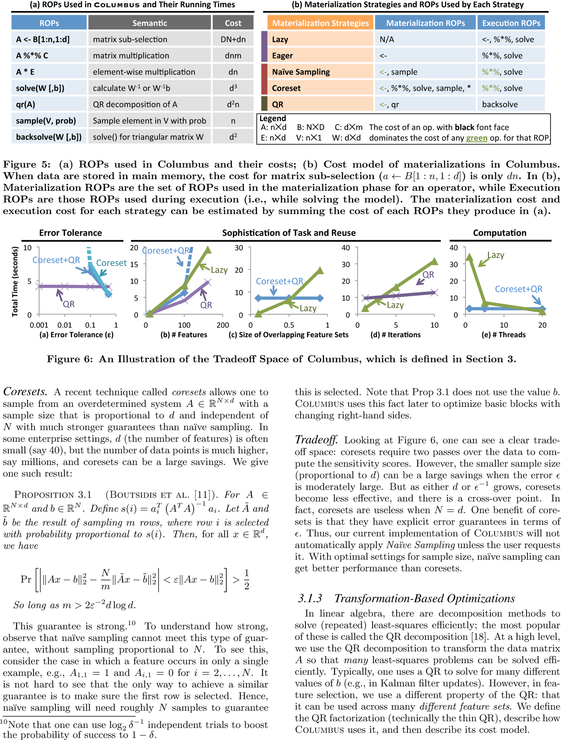
270
Definition 3.1 (Thin QR Factorization). The QR decomposition of a matrix A ∈ RN×d is a pair of matrices (Q,R) where Q ∈ RN×d, R ∈ Rd×d, and A=QR. Q is an orthogonal matrix, i.e., QT Q = I and R is upper triangular.
We observe that since Q−1 = QT and R is upper trian- gular, one can solve Ax = b by setting QRx = b and mul- tiplying through by the transpose of Q so that Rx = QT b. Since R is upper triangular, one can solve can this equation with back substitution; back substitution does not require computing the inverse of R, and its running time is linear in the number of entries of R, i.e., O(d2).
Columbus leverages a simple property of the QR factor- ization: upper triangular matrices are closed under multi- plication, i.e., if U is upper triangular, then so is RU. Since ΠF is upper triangular, we can compute many QR factor- izations by simply reading off the inverse of RΠF .11 This simple observation is critical for feature selection. Thus, if there are several different row selectors, Columbus creates a separate QR factorization for each.
Tradeoff. As summarized in Figure 5, QR’s materialization cost is similar to importance sampling. In terms of execution time, Figure 6 shows that QR can be much faster than core- sets: solving the linear system is quadratic in the number of features for QR but cubic for coresets (without QR). When there are a large number of feature sets and they overlap, QR can be a substantial win (this is precisely the case when coresets are ineffective). These techniques can also be com- bined, which further modifies the optimal tradeoff point. An additional point is that QR does not introduce error (and is often used to improve numerical stability), which means that QR is applicable in error tolerance regimes when sampling methods cannot be used.
3.1.4 Discussion of Tradeoff Space
Figure 6 shows the crossover points for the tradeoffs we de- scribed in this section for the Census dataset. We describe why we assert that each of the following aspects affects the tradeoff space.
Error. For error-tolerant computation, na ̈ıve random sam- pling provides dramatic performance improvements. How- ever, when low error is required, then one must use classical database optimizations or the QR optimization. In between, there are many combinations of QR, coresets, and sampling that can be optimal. As we can see in Figure 6(a), when the error tolerance is small, coresets are significantly slower than QR. When the tolerance is 0.01, the coreset we need is even larger than the original data set, and if we force Colum- bus to run on this large coreset, it would be more than 12x slower than QR. For tolerance 0.1, coreset is 1.82x slower than QR. We look into the breakdown of materialization time and execution time, and we find that materialization time contributes to more than 1.8x of this difference. When error tolerance is 0.5, Coreset+QR is 1.4x faster than QR. We ignore the curve for Lazy and Eager because they are insensitive to noises and are more than 1.2x slower than QR.
Sophistication. One measure of sophistication is the num- ber of features the analyst is considering. When the number
11Notice that ΠRQ is not necessarily orthogonal, so ΠRQ may be expensive to invert.
of features in a basic block is much smaller than the data set size, coresets create much smaller but essentially equivalent data sets. As the number of features, d, increases, or the error decreases, coresets become less effective. On the other hand, optimizations, like QR, become more effective in this regime: although materialization for QR is quadratic in d, it reduces the cost to compute an inverse from roughly d3 to d2.
As shown in Figure6(b), as the number of features grows, CoreSet+QR slows down. With 161 features, the coreset will be larger than the original data set. However, when the number of features is small, the gap between CoreSet+QR and QR will be smaller. When the number of features is 10, CoreSet+QR is 1.7x faster than QR. When the number of feature is small, the time it takes to run a QR decomposition over the coreset could be smaller than over the original data set, hence, the 1.7x speedup of CoreSet+QR over QR.
Reuse. In linear models, the amount of overlap in the fea- ture sets correlates with the amount of reuse. We randomly select features but vary the size of overlapping feature sets. Figure6(c) shows the result. When the size of the over- lapping feature sets is small, Lazy is 15x faster than Core- Set+QR. This is because CoreSet wastes time in material- izing for a large feature set. Instead, Lazy will solve these problems independently. On the other hand, when the over- lap is large, CoreSet+QR is 2.5x faster than Lazy. Here, CoreSet+QR is able to amortize the materialization cost by reusing it on different models.
Available Parallelism. If there is a large amount of paral- lelism and one needs to scan the data only once, then a lazy materialization strategy is optimal. However, in feature se- lection workloads where one is considering hundreds of mod- els or repeatedly iterating over data, parallelism may be lim- ited, so mechanisms that reuse the computation may be op- timal. As shown by Figure 6(e), when the number of threads is large, Lazy is 1.9x faster than CoreSet+QR. The reason is that although the reuse between models is high, all of these models could be run in parallel in Lazy. Thus, although CoreSet+QR does save computation, it does not improve the wall-clock time. On the other hand, when the number of threads is small, CoreSet+QR is 11x faster than Lazy.
3.2 A Single, Non-linear Basic Block
We extend our methods to non-linear loss functions. The same tradeoffs from the previous section apply, but there are two additional techniques we can use. We describe them below.
Recall that a task solves the problem
x∈Rd
N i=1
l(zi, bi) subject to z = Ax where l : R2 → R+ is a convex function.
Iterative Methods. We select two methods: stochastic gra- dient descent (SGD) [8,10,29], and iterative reweighted least squares (IRLS), which is implemented in R’s generalized lin- ear model package.12 We describe an optimization, warm- starting, that applies to such models as well as to ADMM.
12stat.ethz.ch/R-manual/R-patched/library/stats/ html/glm.html
min
271
ADMM. There is a classical, general purpose method that allows one to decompose such a problem into a least-squares problem and a second simple problem. The method we ex- plore is one of the most popular, called the Alternating Di- rection Method of Multipliers (ADMM) [13], which has been widely used since the 1970s. We explain the details of this method to highlight a key property that allows us to reuse the optimizations from the previous section.
ADMM is iterative and defines a sequence of triples (xk,zk,uk) for k = 0,1,2,.... It starts by randomly initial- izing the three variables (x0, z0, u0), which are then updated by the following equations:
argmin ρ||Ax − z(k) + u(k)||2 x2
ods like gradient descent or ADMM, we should be able to partially reuse these similar models. We identify three situ- ations in which such reuse occurs in feature-selection work- loads: (1) We downsample the data, learn a model on the sample, and then train a model on the original data. (2) We perform stepwise removal of a feature in feature selection, and the “parent” model with all features is already trained. (3) We examine several nearby feature sets interactively. In each case, we should be able to reuse the previous models, but it would be difficult for an analyst to implement effec- tively in all but the simplest cases. In contrast, Columbus can use warmstart to achieve up to 13x performance im- provement for iterative methods without user intervention.
Given a cache of models, we need to choose a model: we observe that computing the loss of each model on the cache on a sample of the data is inexpensive. Thus, we select the model with the lowest sampled loss. To choose models to evict, we simply use an LRU strategy. In our workloads, the cache does not become full, so we do not discuss it. However, if one imagines several analysts running workloads on similar data, the cache could become a source of challenges and optimizations.
3.4 Multiblock Optimization
There are two tasks we need to do across blocks: (1) We need to decide on how coarse or fine to make a basic block, and (2) we need to execute the sequence of basic blocks across the backend.
Multiblock Logical Optimization. Given a sequence of basic blocks from the parser, Columbus must first decide how coarse or fine to create individual blocks. Cross val- idation is, for example, merged into a single basic block. In Columbus, we greedily improve the cost using the ob- vious estimates from Figure 5. The problem of deciding the optimal partitioning of many feature sets is NP-hard by a reduction to WeightedSetCover, which we explain in the full version of the paper. The intuition is clear, as one must cover all the different features with as few basic blocks as possible. However, the heuristic merging can have large wins, as operations like cross validation and grid searching parameters allow one to find opportunities for reuse.
Cost-based Execution. Recall that the executor of Colum- bus executes ROPs by calling the required database or main- memory backend. The executor is responsible for executing and coordinating multiple ROPs that can be executed in parallel; Columbus executor simply creates one thread to manage each of these ROPs. The actual execution of each physical operator is performed by the backend statistical framework, e.g., R or ORE. Nevertheless, we need to de- cide how to schedule these ROPs for a given program. We experimented with the tradeoff of how coarsely or finely to batch the execution. Many of the straightforward formula- tions of the scheduling problems are, not surprisingly, NP- hard. Nevertheless, we found that a simple greedy strategy (to batch as many operators as possible, i.e., operators that do not share data flow dependencies) was within 10% of the optimal schedule obtained by a brute-force search. After dig- ging into this detail, we found that many of the host-level substrates already provide sophisticated data processing op- timizations (e.g. sharing scans). Since this particular set of optimizations did not have a dramatic effect on the runtime
x(k+1) = (k+1)
N ρ(k+1) (k)2 argmin l(zi,bi)+ ||Ax −z+u ||2
z=
zi=1 2 u(k) + Ax(k+1) − z(k+1)
u(k+1) =
The constant ρ ∈ (0, 2) is a step size parameter that we set by a grid search over 5 values.
There are two key properties of the ADMM equations that are critical for feature selection applications:
(1) Repeated Least Squares. The solve for x(k+1) is a lin- ear basic block from the previous section since z and u are fixed and the A matrix is unchanged across iteration. In nonlinear basic blocks, we solve multiple feature sets con- currently, so we can reuse the transformation optimizations of the previous section for each such update. To take ad- vantage of this, Columbus logically rewrites ADMM into a sequence of linear basic blocks with custom R functions.
(2) One-dimensional z. We can rewrite the update for z into a series of independent, one-dimensional problems. That is,
(k+1) ρ zi = argmin l(zi, bi)+
2
(k+1)
(k)
zi 2
(qi−zi) , where q = Ax
+u
This one-dimensional minimization can be solved by fast methods, such as bisection or Newton. To update x(k+1), the bottleneck is the ROP “solve,” whose cost is in Figure 5. The cost of updating z and u is linear in the number of rows in A, and can be decomposed into N problems that may be solved independently.
Tradeoffs. In Columbus, ADMM is our default solver for non-linear basic blocks. Empirically, on all of our applica- tions in our experiments, if one first materializes the QR computation for the least-squares subproblem, then we find that ADMM converges faster than SGD to the same loss. Moreover, there is sharing across feature sets that can be leveraged by Columbus in ADMM (using our earlier opti- mization about QR). One more advanced case for reuse is when we must fit hyperparameters, like ρ above or regu- larization parameters; in this case, ADMM enables oppor- tunities for high degrees of sharing. We cover these more complex cases in the full version of this paper.
3.3 Warmstarting by Model-Caching
In feature selection workloads, our goal is to solve a model after having solved many similar models. For iterative meth-
272
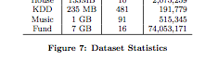
<#$# ,"$ ?&2@&#A
 | !"#$%&"' | )%*+"' | ,-." | / 0#'-1 0+213' | / )#'3' 40#'-1 0+213 | / 5-6"' 27 829"' | ):*" 27 0#'-1 0+213'
;<< | !"# | #%# & | '() *+ | , | #- | '" | , ./ +01234
8"6'%' | #,# | #-% & | #-- *+ | ! | -5' & | #, | ( .6 +01234 # ./ +0123
=%'-1 | %# | )#) & | # 7+ | ! | -5# & | #, | ( .6 +01234 # ./ +0123
!%69 | #, | 8! * | 8 7+ | # | '5) & | ! | # .6 +0123
>2%'" | #- | ' * | #(( *+ | # | #5- & | ! | # .6 +0123
Figure 7: Dataset and Program Statistics. LS refers to Least Sqaures. LR refers to Logistic Regression.
for any of our data sets, we report them only in the full version of this paper.
4. EXPERIMENTS
Using the materialization tradeoffs we have outlined, we validate that Columbus is able to speed up the execution of feature selection programs by orders of magnitude compared to straightforward implementations in state-of-the-art sta- tistical analytics frameworks across two different backends: R (in-memory) and a commercial RDBMS. We validate the details of our technical claims about the tradeoff space of materialization and our (preliminary) multiblock optimizer.
4.1 Experiment Setting
Based on conversations with analysts, we selected a hand- ful of datasets and created programs that use these datasets to mimic analysts’ tasks in different domains. We describe these programs and other experimental details.
Datasets and Programs. To compare the efficiency of Columbus with baseline systems, we select five publicly available data sets: (1) Census, (2) House, (3) KDD, (4) Music, and (5) Fund.13 These data sets have different sizes, and we show the statistics in Figure 7. We categorize them by the number of features in each data set.
Both House, a dataset for predicting household electronic usage, and Fund, a dataset for predicting the donation that a given agency will receive each year, have a small number of features (fewer than 20). In these data sets, it is feasible to simply try and score almost all combinations of features. We mimic this scenario by having a large basic block that regresses a least-squares model on feature sets of sizes larger than 5 on House and 13 on Fund and then scores the re- sults using AIC. These models reflect a common scenario in current enterprise analytics systems.
At the other extreme, KDD has a large number of fea- tures (481), and it is infeasible to try many combinations. In this scenario, the analyst is guided by automatic algorithms, like lasso (that selects a few sparse features), manual inter- vention (moving around the feature space), and heavy use of cross-validation techniques.14 Census is a dataset for the task of predicting mail responsiveness of people in different Census blocks, each of which contains a moderate number of
13These data sets are publicly available on Kaggle (www. kaggle.com/) or the UCI Machine Learning Repository. (archive.ics.uci.edu/ml/)
14The KDD program contains six basic blocks, each of which is a 10-fold cross-validation. These 6 different basic blocks work on non-overlappings set of features specified by the user manually.
features (161). In this example, analysts use a mix of auto- matic and manual specification tasks that are interleaved.15 This is the reason that we select this task for our running example. Music is similar to Census, and both programs contain both linear models (least squares) and non-linear models (logistic regression) to mimic the scenario in which an analyst jointly explores the feature set to select and the model to use.
R Backends. We implemented Columbus on multiple back- ends and report on two: (1) R, which is the standard, main- memory R and (2) DB-R, commercial R implementation over RDBMS. We use R 2.15.2, and the most recent avail- able versions of the commercial systems.
For all operators, we use the result of the corresponding main memory R function as the gold standard. All exper- iments are run on instances on Amazon EC2 (cr1.8xlarge), which has 32 vCPU, 244 GB RAM, and 2x120GB SSD and runs Ubuntu 12.04.16
4.2 End-to-End Efficiency
We validate that Columbus improves the end-to-end performance of feature selection programs. We construct two families of competitor systems (one for each backend): Vanilla, and dbOPT. Vanilla is a baseline system that is a straightforward implementation of the corresponding feature selection problem using the ROPs; thus it has the standard optimizations. dbOPT is Columbus, but we en- able only the optimizations that have appeared in classical database literature, i.e., Lazy, Eager, and batching. dbOPT and Columbus perform scheduling in the same way to im- prove parallelism to isolate the contributions of the materi- alization. Figure 8 shows the result of running these systems over all five data sets with error tolerance ǫ set to 0.01.
On the R-based backend, Columbus executes the same program using less time than R on all datasets. On Census, Columbus is two orders of magnitude faster, and on Music and Fund, Columbus is one order of magnitude faster. On Fund and House, Columbus chooses to use CoreSet+QR as the materialization strategy for all basic blocks and chooses to use QR for other data sets. This is because for data sets that contain fewer rows and more columns, QR dominates CoreSet-based approaches, as described in the previous Sec- tion. One reason that Columbus improves more on Census than on Music and Fund is that Census has more features than Music and Fund; therefore, operations like StepDrop produce more opportunities for reuse than Census.
To understand the classical points in the tradeoff space, compare the efficiency of dbOPT with the baseline system, Vanilla. When we use R as a backend, the difference be- tween dbOPT and R is less than 5%. The reason is that R holds all data in memory, and accessing a specific por- tion of the data does not incur any IO cost. In contrast, we observe that when we use the DB backend, dbOPT is 1.5x faster than Vanilla on House. However, this is because the underlying database is a row store, so the time difference is due to IO and deserialization of database tuples.
15The Census program contains four basic blocks, each of which is a StepDrop operation on the feature set output by the previous basic block.
16We also run experiments on other dedicated machines. The tradeoff space is similar to what we report in this paper.
273
-20 A B2$C#(/
-40 DBEA B2$C#(/
-$0 :#.+'( 8?%/< '( 7#(.%.
!#### !### !## !# !
12(+332
56*
'3%,4%.
$%% &'()*) +*),- .*(/ 01*)'
!##### !#### !### !## !# !
!3265
$%% &'()*) +*),- .*(/ 01*)'
/4
7
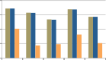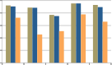
:2;<
!945
!2=#>
7'>#8#?
@A
83'9/'9(
2345
!3!5
!365
47385

Figure 8: End-to-end Performance of Columbus. All approaches return a loss within 1% optimal loss.

We can also see that the new forms of reuse we outline are significant. If we compare the execution time of Cen- sus and Music, we see a difference between the approaches. While Census is smaller than Music, baseline systems, e.g., Vanilla, are slower on Census than on Music. In contrast, Columbus is faster on Census than on Music. This is be- cause Census contains more features than Music; therefore, the time that Vanilla spent on executing complex oper- ators like StepDrop is larger in Census. In contrast, by exploiting the new tradeoff space of materialization, Colum- bus is able to reuse computation more efficiently for feature selection workloads.
4.3 Linear Basic Blocks
We validate that all materialization tradeoffs that we iden- tified affect the efficiency of Columbus. In Section 3, we de- signed experiments to understand the tradeoff between dif- ferent materialization strategies with respect to three axes, i.e., error tolerance, sophistication of tasks and reuse, and computation. Here, we validate that each optimization con- tributes to the final results in a full program (on Census). We then validate our claim that the cross-over points for op- timizations change based on the dataset but that the space essentially stays the same. We only show results on the main-memory backend.
Lesion Study. We validate that each materialization strat- egy has an impact on the performance of Columbus. For each parameter setting used to create Figure 6, we remove a materialization strategy. Then, we measure the maximum slowdown of an execution with that optimization removed. We report the maximum slowdown across all parameters in Figure 8(c) in main memory on Census. We see that Lazy, QR, and CoreSet all have significant impacts on qual- ity, ranging from 1.9x to 37x. This means that if we drop any of them from Columbus, one would expect a 1.9x to 37x slowdown on the whole Columbus system. Similar observa- tions hold for other backends. The only major difference is that our DB-backend is a row store, and Eager has a larger impact (1.5x slowdown).
We validate our claim that the high-level principles of the tradeoffs remain the same across datasets, but we contend that the tradeoff points change across data sets. Thus, our work provides a guideline about these tradeoffs, but it is still difficult for an analyst to choose the optimal point. In particular, for each parameter setting, we report the name of the materialization strategy that has the fastest execu- tion time. Figure 9 shows that across different data sets, the same pattern holds, but with different crossover points.
Figure 9: Robustness of Materialization Tradeoffs Across Datasets. For each parameter setting (one column in the table), we report the materialization strategy that has the fastest execution time given the parameter setting. Q refers to QR, C refers to CoreSet+QR, and L refers to Lazy. The protocol is the same as Figure 6 in Section 3.
Consider the error tolerance. On all data sets, for high er- ror tolerance, CoreSet+QR is always faster than QR. On Census and KDD, for the lowest three error tolerances, QR is faster than CoreSet+QR, while on Music, only for the lowest two error tolerance is QR faster than CoreSet+QR. While on Fund and House, for all error tolerances except the lowest one, CoreSet+QR is faster than QR. Thus, the cross-over point changes.
4.4 Non-Linear Basic Blocks with ADMM
Columbus uses ADMM as the default non-linear solver, which requires that one solves a least-squares problem that we studied in linear basic blocks. Compared with linear ba- sic blocks, one key twist with ADMM is that it is iterative– thus, it has an additional parameter, the number of itera- tions to run. We validate that tradeoffs similar to the linear case still apply to non-linear basic blocks, and we describe how convergence impacts the tradeoff space. For each data set, we vary the number of iterations to run for ADMM and try different materialization strategies. For CoreSet-based approaches, we grid search the error tolerance, as we did for the linear case. As shown in Figure 6(d), when the number of iterations is small, QR is 2.24x slower than Lazy. Because there is only one iteration, the least-squares problem is only solved once. Thus, Lazy is the faster strategy compared with QR. However, when the number of iterations grows to 10, QR is 3.8x faster than Lazy. This is not surprising based on our study for linear cases–by running more iterations, the opportunities for reuse increase. We expect an even larger speedup if we run more iterations.
011/1 2/3"14#+" 5 ,"46%1"$ 78"13499*#: 5 2;1"4-$
!"!!# !"!# !"# !"& !"#$ !"&$ #$ !"# !"& # # & *!

' ' '
' '
)
( (
274
!"#$%$
(
(
(
)
)
(
(
)
'((
' ' '
(
(
' '
(
( (
)
)%$*+
' '
(
(
(
'
(
(
(
( (
)
,%#-
'
(
(
(
(
(
(
( (
./%$"
'
(
( ( (
(
( ( (
(
( (
(
( (
)
)
,"<"1 =%>?"1 /@ ,"46%1"$
!"#$%&'( *+,# -.#$'(/.0
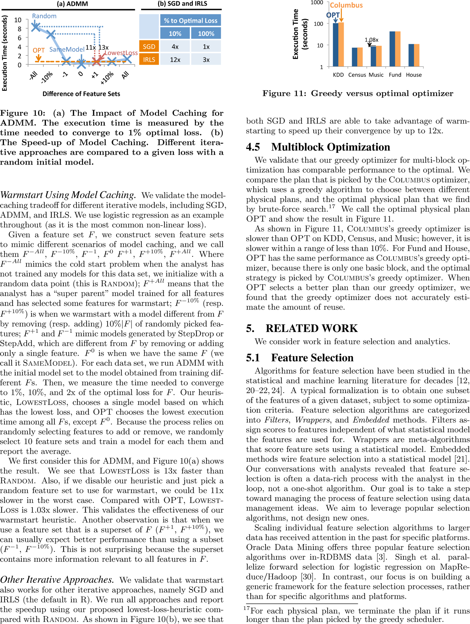
275
5.2 Analytics Systems
Systems that deal with data management for statistical and machine learning techniques have been developed in both industry and academia. These include data mining toolkits from major RDBMS vendors, which integrate spe- cific algorithms with an RDBMS [3,23]. Similar efforts exist for other data platforms [1]. The second stream includes re- cent products from enterprise analytics vendors that aim to support statistical computing languages, like R, over data residing in data platforms, e.g., Oracle’s ORE [4], IBM’s SystemML [17], SAP HANA [5], and the RIOT project [32]. Our work focuses on the data management issues in the pro- cess of feature selection, and our ideas can be integrated into these systems.
Array databases were initiated by Sarawagi et al. [28], who studied how to efficiently organize multidimensional arrays in an RDBMS. Since then, there has been a recent resur- gence in arrays as first-class citizens [14,15,31]. For example, Stonebraker et al. [31] recently envisioned the idea of using carefully optimized C++ code, e.g., ScaLAPACK, in array databases for matrix calculations. Our Columbus system is complementary to these efforts, as we focus on how to optimize the execution of multiple operations to facilitate reuse. The materialization tradeoffs we explore are (largely) orthogonal to these lower-level tradeoffs.
There has been an intense effort to scale up individual lin- ear algebra operations in data processing systems [9,16,32]. Constantine et al. [16] propose a distributed algorithm to calculate QR decomposition using MapReduce, while ScaLA- PACK [9] uses a distributed main memory system to scale up linear algebra. The RIOT [32] system optimizes the I/O costs incurred during matrix calculations. Similar to array databases, Columbus directly takes advantage these tech- niques to speed up the execution of each ROP.
Our focus on performance optimizations across full pro- grams was inspired by similar efforts in RIOT-DB [32] and SystemML [17]. RIOT-DB optimizes I/O by rearranging page accesses for specific loop constructs in an R program [32]. SystemML [17] converts R-style programs to workflows of MapReduce jobs. They describe an optimization called pig- gybacking, which enables sharing of data access by jobs that follow each other.
In a similar spirit, declarative machine learning systems, e.g., MLBase [26], provide the end users a high-level lan- guage to specify a machine learning task. Compared with these systems, Columbus focuses on providing a high-level language for feature selection as opposed to algorithms. The conventional wisdom is that most improvement comes through good features as opposed to different algorithms. We are hopeful that the materialization tradeoffs that we study can be applied in declarative machine learning systems.
6. CONCLUSION
Columbus is the first system to treat the feature selec- tion dialogue as a database systems problem. Our first contribution is a declarative language for feature selection, informed by conversations with analysts over the last two years. We observed that there are reuse opportunities in analysts’ workloads that are not addressed by today’s R backends. To demonstrate our point, we showed that simple materialization operations could yield orders of magnitude performance improvements on feature selection workloads.
As analytics grows in importance, we believe that feature selection will become a pressing data management problem.
Acknowledgment. We gratefully acknowledge the support of Ora- cle, the Office of Naval Research under awards No. N000141210041 and No. N000141310129, the National Science Foundation CAREER Award under No. IIS-1353606, Sloan Research Fellowship, and Amer- ican Family Insurance. Any opinions, findings, and conclusion or rec- ommendations expressed in this material are those of the authors and do not necessarily reflect the view of ONR, NSF, or the US govern- ment.
7. REFERENCES
- [1] Apache Mahout. mahout.apache.org.
- [2] Feature Selection and Dimension Reduction Techniques in SAS. nesug.org/Proceedings/nesug11/sa/sa08.pdf.
- [3] Oracle Data Mining. oracle.com/technetwork/database/options/ advanced-analytics/odm.
- [4] Oracle R Enterprise. docs.oracle.com/cd/E27988_01/doc/doc.112/e26499.pdf.
- [5] SAP HANA and R. help.sap.com/hana/hana_dev_r_emb_en.pdf.
- [6] SAS Report on Analytics. sas.com/reg/wp/corp/23876.
- [7] Variable Selection in the Credit Card Industry. nesug.org/proceedings/nesug06/an/da23.pdf.
- [8] D. Bertsekas. Nonlinear Programming. Athena Scientific, 1999.
- [9] L. S. Blackford and et al. ScaLAPACK: A portable linear algebra library for distributed memory computers - design issues and performance. In SuperComputing, 1996.
- [10] L. Bottou and O. Bousquet. The tradeoffs of large scale learning. In NIPS, 2007.
- [11] C. Boutsidis and et al. Near-optimal coresets for least-squares regression. IEEE Transactions on Information Theory, 2013.
- [12] D. Boyce and et al. Optimal Subset Selection. Springer, 1974.
- [13] S. Boyd and et al. Distributed optimization and statistical learning via the alternating direction method of multipliers. Found. Trends Mach. Learn., 2011.
- [14] P. G. Brown. Overview of sciDB: Large scale array storage, processing and analysis. In SIGMOD, 2010.
- [15] J. Cohen and et al. MAD skills: New analysis practices for big data. PVLDB, 2009.
- [16] P. G. Constantine and D. F. Gleich. Tall and skinny qr factorizations in mapreduce architectures. In MapReduce, 2011.
- [17] A. Ghoting and et al. SystemML: Declarative machine learning on MapReduce. In ICDE, 2011.
- [18] G. Golub. Numerical methods for solving linear least squares problems. Numerische Mathematik, 1965.
- [19] G. Graefe and W. J. McKenna. The Volcano optimizer generator: Extensibility and efficient search. In ICDE, 1993.
- [20] I. Guyon and A. Elisseeff. An introduction to variable and feature selection. JMLR, 2003.
- [21] I. Guyon and et al. Feature Extraction: Foundations and Applications. New York: Springer-Verlag, 2001.
- [22] T. Hastie and et al. The Elements of Statistical Learning: Data mining, inference, and prediction. Springer, 2001.
- [23] J. Hellerstein and et al. The MADlib analytics library or MAD skills, the SQL. In PVLDB, 2012.
- [24] G. H. John and et al. Irrelevant features and the subset selection problem. In ICML, 1994.
- [25] S. Kandel and et al. Enterprise data analysis and visualization: An interview study. IEEE Trans. Vis. Comput. Graph., 2012.
- [26] T. Kraska and et al. MLbase: A distributed machine-learning system. In CIDR, 2013.
- [27] M. Langberg and L. J. Schulman. Universal ǫ-approximators for integrals. In SODA, 2010.
- [28] S. Sarawagi and M. Stonebraker. Efficient organization of large multidimensional arrays. In ICDE, 1994.
- [29] S. Shalev-Shwartz and N. Srebro. SVM optimization: Inverse dependence on training set size. In ICML, 2008.
- [30] S. Singh and et al. Parallel large scale feature selection for logistic regression. In SDM, 2009.
- [31] M. Stonebraker and et al. Intel “big data” science and technology center vision and execution plan. SIGMOD Rec., 2013.
- [32] Y. Zhang and et al. I/O-efficient statistical computing with RIOT. In ICDE, 2010.
276

